RYEDALE CARERS SUPPORT
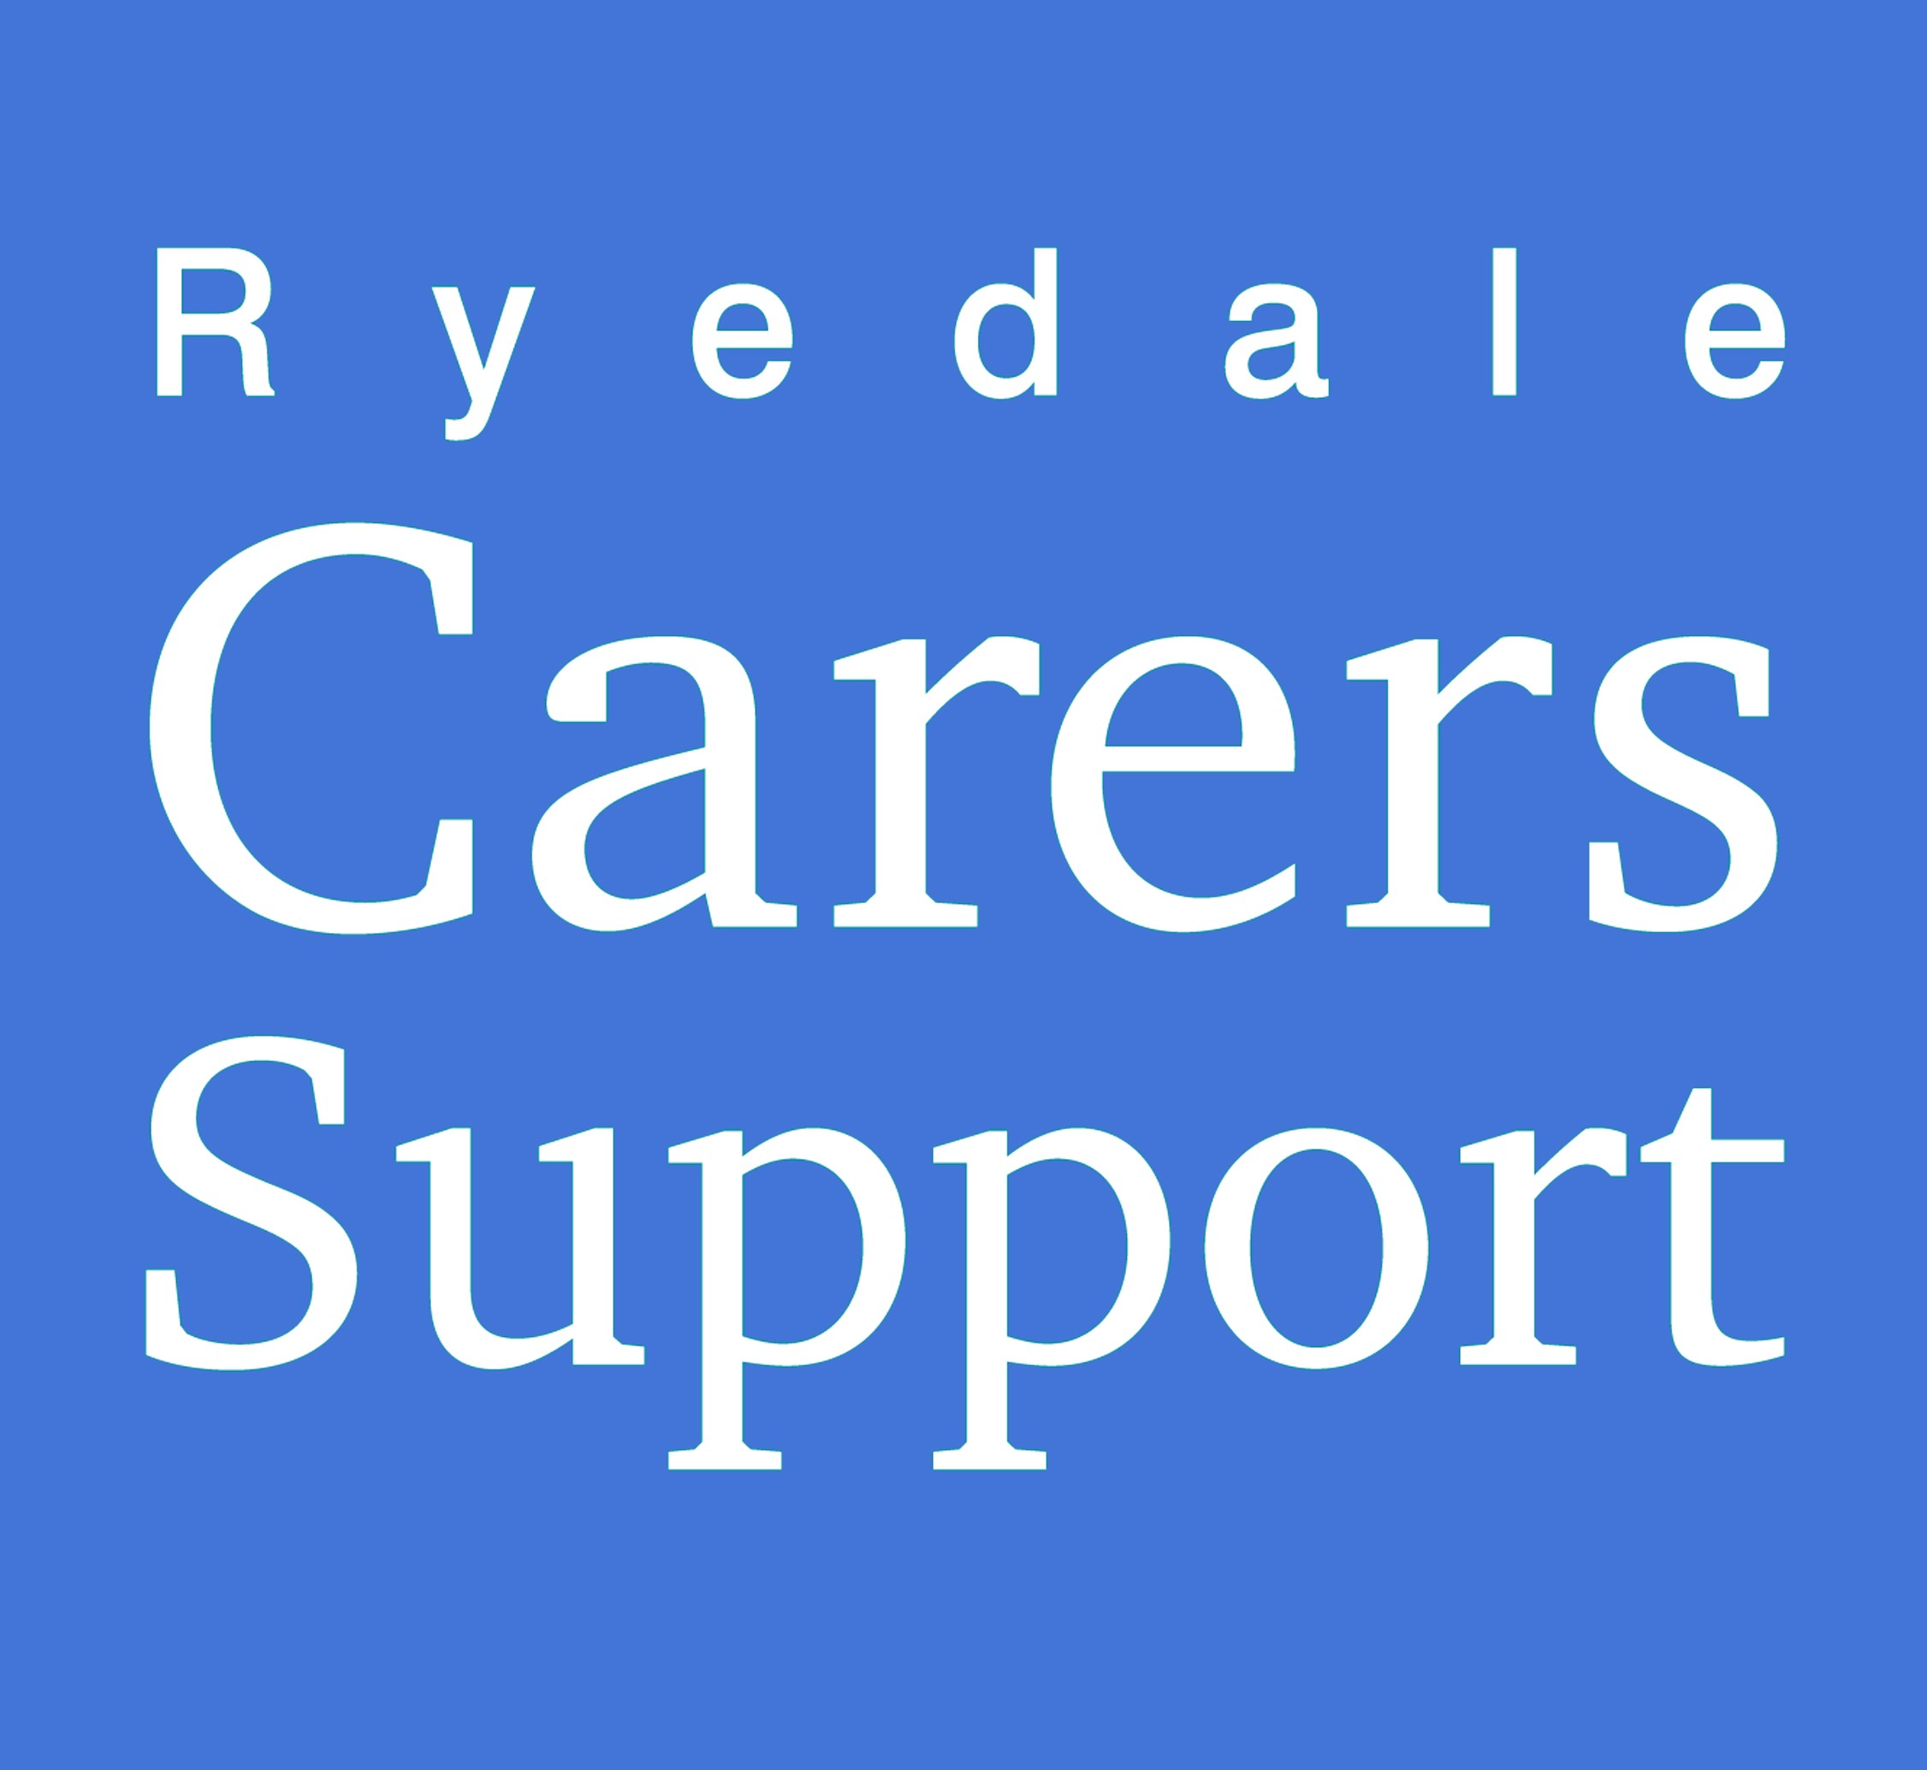
Charity Registration No 1175552
The Old School
Tinley Garth
Kirkbymoorside
YO62 6AR

Telephone (01751) 432288

Date | Details of Journey | Miles Driven | Public Transport (£)
 | Total Mileage
Total Amount (£)
@ 40p per mile

Name & Address of Claimant… ………………………………………………………………………………………………………………………………….
…………………………………………………………………………………………………………………………………. Postcode…………………
PLEASE NOTE that it is your responsibility to ensure that your insurance, MOT and Driving Licence are up to date

For Office Use
Payment Authorised

Cheque No
Signature of Claimant

